Get In the Wheelbarrow
By: Scott Dane – Executive Director, American Loggers Council

Superbowl Champion Quarterback Kurt Warner sent a letter to the American Loggers Council that was shared at the Annual Conference. In it, Kurt conveys a story regarding a symbolic reminder to the 1999 Superbowl Champion, St. Louis Rams football team during their practices. Their coach Dick Vermeil had a blue wheelbarrow on the sidelines. It was a visual motivational reminder to inspire the team and was based on the following story:

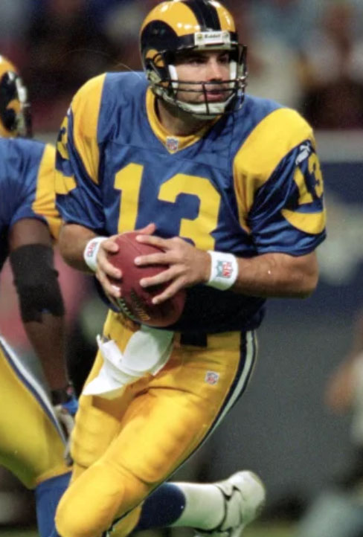
There once was a man who traveled from town to town performing a tightrope act. In one town he proclaimed that he would walk on a rope spanning a nearby wide river canyon. He boasted he would do it pushing a wheelbarrow.

Townsfolk didn’t believe him, so he practiced flawlessly just five feet off of the ground on a rope tied between a pair of trees. After seeing the tightrope walker practice one farmer said he believed the man could cross the river canyon. He even bet $10 to prove his faith in the man’s skills.

The man asked the farmer if he really had faith that he could do it? The farmer said, “I sure do.” The tightrope walker said, “Okay, get in the wheelbarrow!”

The moral of the story is some believers stand on the sidelines and believers that get in the wheelbarrow. Kurt’s letter closes with:

“Success in any field begins with faith. Faith in yourself. Faith in your teammates. Faith in coaches. And in my case faith in God. The championship teams that I played with had faith. We climbed in the wheelbarrow together. So – Keep the Faith”

Kurt Warner was an American underdog who got his chance to play for the St. Louis Rams in 1999 after having been passed over by other teams. The American Loggers Council got its chance in St. Louis Missouri in 1994 when the “team” was formed by a bunch of American underdogs who had faith – faith in themselves, faith in each other and faith in God. They got in the wheelbarrow together and over the past 28 years crossed many canyons while building a championship team. They didn’t stand on the sidelines, they got in the game. They took the hits, but they carried the ball and scored! The American Loggers Council is a championship team!

Kurt also autographed a poster titled Legacy which said:

“Legacy – Live a Life that Inspires Others to Dream Bigger, Try Harder, Do Better and Accomplish the Unexpected.”

Those that came together to form the American Loggers Council in Missouri in 1994 have left a legacy because they inspired others to dream bigger, try harder, do better and accomplish the unexpected. They had faith and got into the wheelbarrow. Today’s American Loggers Council is their legacy. Some of them were in Branson and were recognized. Representing the first President, Earl St. Johns was his grandson, Jordan St. Johns, and his great-grandson. Also present and recognized were inaugural representatives Jim Carey (MI) and Eric Mayranen (MN) and Charles Johns (FL). Representing Marvin Zuber (OR) was his son, Bruce Zuber, Western Regional Representative of the American Loggers Council.

The legacy of the American logger has been recognized. It was announced at the conference that a Resolution was introduced in the U.S. Senate to designate October 12th as National Loggers Day. This resolution honors the American Logger for their role in building America; producing products for Americans from the renewable timber harvested; creating jobs; and forest management which results in healthy forests that provide recreational opportunities, animal habitat, clean water, carbon sequestration and reduction of wildfires. The designation of this National Loggers Day was achieved because (team) members of the American Loggers Council worked together to garner this overdue national recognition. So loggers, on October 12th, take a moment to proudly reflect on what you do, on what your fathers and grandfathers did, and how it contributes to building America every day. Without loggers, America would not be the great country it is today. You are an American legacy.

Kurt Warner and his wife Brenda run the First Things First foundation which is dedicated to impacting lives in a lasting way by promoting Christian values, sharing experiences, and providing opportunities to encourage everyone that all things are possible when people seek to put “first things first”. When Kevin Smith, American Loggers Council Director of Communications and Marketing, contacted the First Things First Foundation and explained to them that the American Loggers Council is the national sponsor of the Log-A-Load For Kids program and that we would be holding a fundraising auction at the conference, Kurt responded with the letter and autographed Legacy poster.

With great success comes great responsibility. Kurt Warner accepts this and so does the American Loggers Council. The ALC has been blessed with success, and, like Kurt, appreciates the responsibility to help others and impact their lives in a positive way. The Log A Load For Kids auction raised over $56,000! In addition, an impromptu auction to support a logger dealing with cancer was conducted. The two items (autographed Duck Dynasty duck calls and Stihl chainsaw) that were donated were auctioned – donated back – then reauctioned - numerous times, raising a total of $38,000.
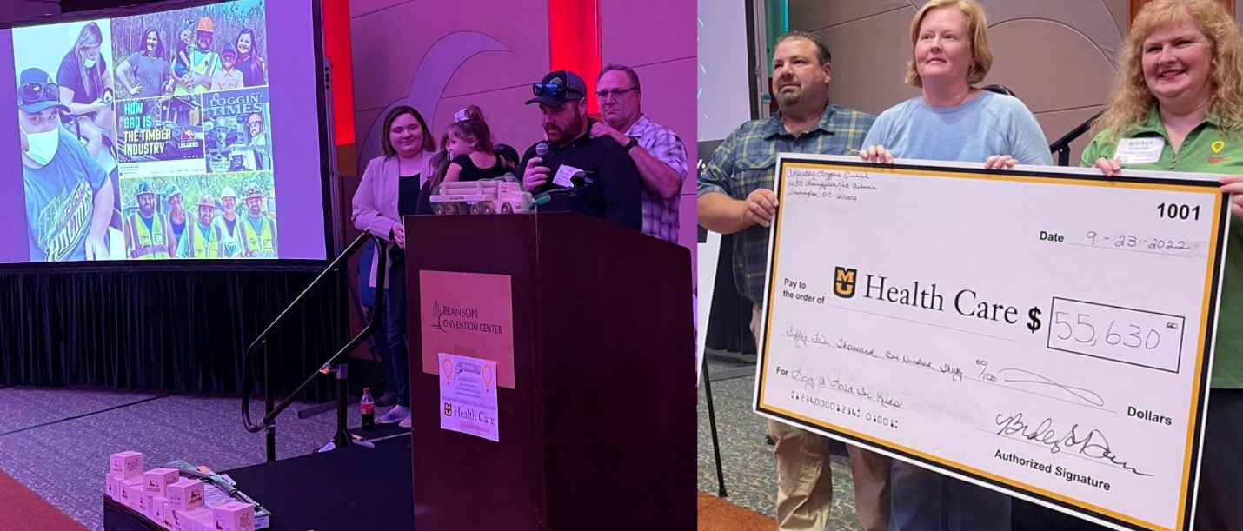

The outpouring of support and generosity demonstrated by loggers from across the country for children in Missouri and a logger in Louisiana was a testimony of the character of the logging community and family.

Two-hundred and fifty timber industry representatives came to Branson Missouri from across the country to represent the American logging industry. They met to discuss and explore “Tomorrow’s Timber Industry”. To share ideas and thoughts, much like loggers did 28 years prior when they formed the American Loggers Council, to ensure that there is a viable future for the next generation. They came together to be responsible corporate stewards and support their communities. They came together to be part of a team, a winning team, and to make a difference – and what a difference they made!

The American Loggers Council now represents loggers in 38 states. If you are reading this, and you are not a member of your state logging association or the American Loggers Council, don’t be a believer that stands on the sidelines, be a believer that gets in the wheelbarrow. Be a part of the team!

