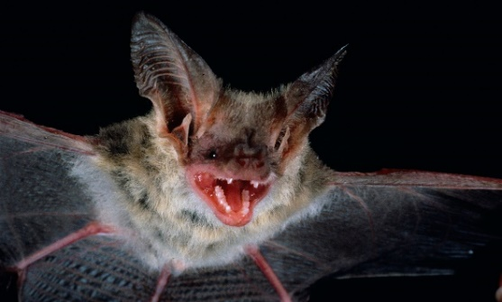
As We See It - April 2022

Northern Long-Eared Bat Endangers Loggers

By: Scott Dane – Executive Director, American Loggers Council

The U.S. Fish and Wildlife Service proposal to change the listing from Threatened to Endangered for the Northern Long-Eared Bat will do nothing to reduce the mortality of the bat, but will contribute to the declining numbers of loggers in the U.S. and threaten the forest products industry.

Let’s examine the facts:
- The Northern Long-Eared Bats are dying from being infected with a fungus that causes the White-Nose Syndrome (WNS), while hibernating in caves during the winter.
- The mortality rate for bats infected with the fungus is 97%-100%. There is no known cure.
- The range of the bats covers 37 states.
- WNS is predicted to be in 100% of its U.S. range by 2025.

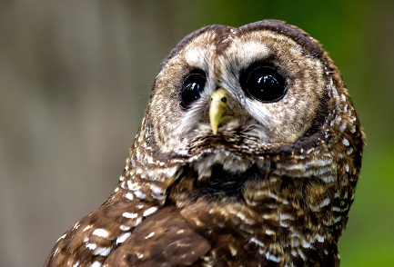
Northern Long-Eared Bat will be the new Spotted Owl.

One of the talking points being promoted by the U.S. Fish and Wildlife Service in support of their efforts to change the listing from Threatened to Endangered is that the bats contribute $3 billion annually to the U.S. agricultural economy through pest control and pollination.

The U.S. Forest Products Industry is one of the largest manufacturing industries in American, representing nearly 4% of manufacturing GDP, $300 billion in products annually and $109 billion in payroll. Over 100 times the so-called economic contribution of the bat.

If the Northern Long-Eared Bat is listed as Endangered it will result in enhanced habitat (forests) protection restrictions, particularly during the summer (June and July) roosting phase. Since it is impossible to accurately identify roosting trees, this will open up a pandora’s box of overreaching limits and restrictions that will impede forest management activities. Furthermore, after the bats, including newborn bats, return to the caves to hibernate, they will be infected with the fungus and die anyway. This prescription will be equivalent to treating a terminal illness (literally for the bats) with an ineffective focus on extenuating factors while ignoring the source of the illness. The medical field has a fundamental principle of “Do No Harm”. The listing of the Northern Long-Eared Bat as Endangered, and the subsequent actions and restrictions that will result, will do harm, particularly to the timber and forest management sectors. Far more harm than good.

The Endangered Species Act was passed by Congress in 1973. In nearly 50 years over 2,000 species have been listed, with only 54 ever being removed due to recovery, and many (34) removed due to extinction. This constitutes only a 2% recovery rate.
A species must satisfy at least one of five listing criteria in order to qualify for listing as a “threatened” or “endangered” species under the Endangered Species Act:

- The present or threatened destruction, modification, or curtailment of its habitat or range;
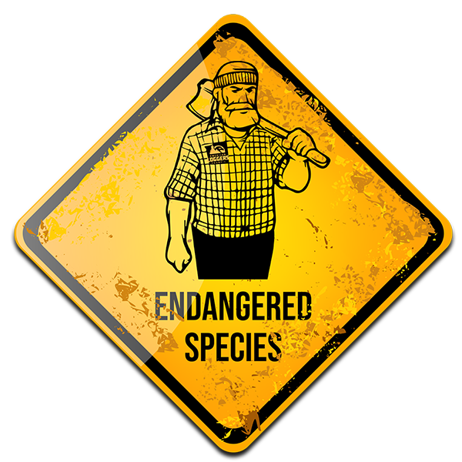
- Overutilization for commercial, recreational, scientific, or educational purposes;
- Disease or predation;
- The inadequacy of existing regulatory mechanisms; or
- Other natural or manmade factors affecting its continued existence.

Based on these criteria the American Logger satisfies more than one and should therefore be considered for listing as “threatened” or “endangered” and afforded the same protections.

