As We See It: FEB 2022

Inflation Threatens to Undermine Timber Industry
Post-Pandemic Economic Recovery

By: Scott Dane, Executive Director – American Loggers Council
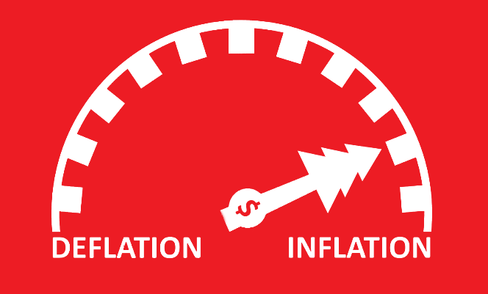
With pandemic illnesses and hospitalizations falling, and restrictions being lifted, it appeared that the worst might just be behind us. The timber industry was deemed essential and worked through the COVID crisis providing the resources to support the production of forest-based products. Most survived, both literally, and businesswise.

However, after over two years of pandemic economic impacts to the U.S. economy, studies concluded that over $1 billion in negative economic impact occurred within the timber industry, due to some mills closing and others taking downtime. Now hyper-inflation has reared its ugly head.

The Bureau of Labor Statistics reported that inflation was 7.5% compared to a year ago, the highest in 40 years. I do not know what type of “new math” or formula they are using, but it doesn’t take a convoluted calculation to feel the “real” inflationary impacts. Just fill up the tank of your logging truck, buy consumables or parts – they’ve all increased by at least 3-4 times the 7.5% rate being reported (this assumes the products are even available due to the breakdown in the supply chain). Additionally, labor costs are increasing as the logging industry competes to attract and retain workers.

The Department of Energy (DOE) documents fuel prices. These are the average diesel prices reported by the DOE across the country:

February 2020 February 2021 February 2022
$2.95 / Gallon $2.71 / Gallon $3.95 / Gallon

*With California reporting $4.94 / Gallon
“The cost of fuel has now risen to $4.30/gallon in northern Wisconsin.”
-Wisconsin Logger

“I have been in the trucking business for over 40 years. The availability of parts, tires, filters are at a level not seen in the past.” -Minnesota Trucker

“A set of four tires for a F-350 pickup cost $2,012 two weeks ago, $400 more than at this time last year.” -Idaho Trucker

“A pallet of bar and chain oil last year was $1,300, today it is $2,000.”
-Missouri Logger

“Slasher saw blade was $1,888, now it’s $2,958. Tracks and chains for six-wheel skidder were $20,300, now they are $27,300. Diesel Exhaust Fluid (DEF) was 95 cents per gallon, now it is $2.64 per gallon.” -Maine Logger

“The prices being paid to loggers and truckers are not keeping up to the increased cost of doing business.” -Minnesota Trucker

The numbers don’t add up. At this point, the timber industry would embrace a 7.5% inflationary increase compared to what we are really paying! Unlike other industries that can pass on the additional costs to the consumers, the timber industry does not have that option in most cases. In an industry where half operate at a breakeven or loss and the largest percentage of profitable companies (24%) operate on a 1%-3% profit margin, absorbing these additional costs is not sustainable.

Everybody likes to talk about sustainability within the forest industry, except when it comes to the logger.

The Professional Logging Contractors of Maine has conducted a survey comparing the cost of specific industry items between 2020 and 2022. That data will be available on their website. The American Loggers Council is going to utilize that survey, with a couple of additions, and distribute it nationwide through our databases and state associations. It is imperative that the real inflationary numbers be documented and verifiable to provide credibility when demonstrating the impact to operational and production costs. When the survey is released, please take a moment to complete and submit it. Your participation will assist in developing quantifiable proof of the level and impact that inflation and supply chain interruptions are having on the U.S. timber industry.

