THANKSGIVING PERSPECTIVE

By: Scott Dane – Executive Director, American Loggers Council

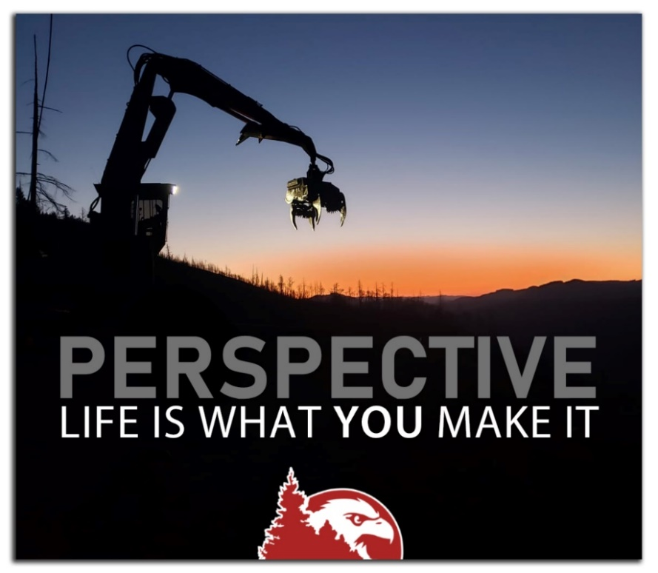
It is a matter of perspective, we can either look at the glass as half full or half empty. Either way it is the same glass, it just depends upon how we choose to look at it. If you are thirsty, you can be grateful for half a glass of water, or you can be resentful that it wasn’t a full glass of water. That is how life, particularly in the woods, can be. Loggers and truckers tend to be “glass half full” optimists.
There are few “easy” days in the woods or hauling timber. The challenges are daily, sometimes hourly. But if you have been in the timber industry, it is a way of life. Honestly, that may be what drives loggers and truckers to do what they do. It is a life most others cannot or will not live. As such you have overcome insurmountable challenges and threats; you have replenished your glass and never let it be empty.
As we prepare for the Thanksgiving celebration, remember that it dates back to colonial times and the harvest feast. When settlers and Native Americans came together and shared a meal. The New England colonists regularly celebrated “days of prayer thanking God for blessings”. Later, a national Thanksgiving Day was officially designated by President Lincoln to promote unity during the Civil War.
If there has been a time since the Civil War that the United States needed unity, it is today. Despite all of the division, vitriol and conflict today’s United States can take a lesson from 400 years ago, when two vastly different cultures, who were at times warring factions, sat together, ate together and gave thanks TOGETHER. This historic demonstration of unity is an example of what America needs today, and a reminder that we still have a lot to be thankful for this Thanksgiving Day.
The timber industry is comprised of competing factions, including loggers vying for the same timber tract, mill volume, laborers, and trucking capacity. Yet most come together to work towards a common mutual benefit of a sustainable timber industry through their membership in state and national organizations. They recognize that through unity a greater good can be achieved. Perhaps there should be more loggers and truckers running the country. Men and women who face the daily challenges of harvesting timber and transporting it, who can solve problems, who are focused on the common good, who build instead of destroy, who focus on the good not the bad, who are thankful for the blessings they have received.
Whether we choose to look at all of the blessings we enjoy today, or if we choose to look at the challenges, differences, threats and disagreements that divide us, is up to each of us.
Gratitude and Attitude are not Challenges; they are Choices.
Thanksgiving is about unity, unity of country, but more importantly, Thanksgiving is about giving thanks to the source of our blessings – God.
Ephesians 6:12 – For we wrestle not against flesh and blood, but against principalities, against powers, against the rulers of the darkness of the world, against spiritual wickedness in high places.
Charles Spurgeon said, “The Lord’s mercy often rides to the door of our heart upon the black horse of affliction.”
During the Thanksgiving holiday, be sure to have the right perspective, count your blessings – your health, your family, your business and give thanks to the One from whom all blessings flow. Even in the challenges be thankful.
Be Thankful for Every New Challenge. It will Build Strength, Wisdom, and Character.
With that perspective, in times of blessings and in times of challenges, we can be thankful and give thanks.
“The secret of happiness is to count your blessings while others are adding up their troubles.”
–William Penn (American Colonialist)

