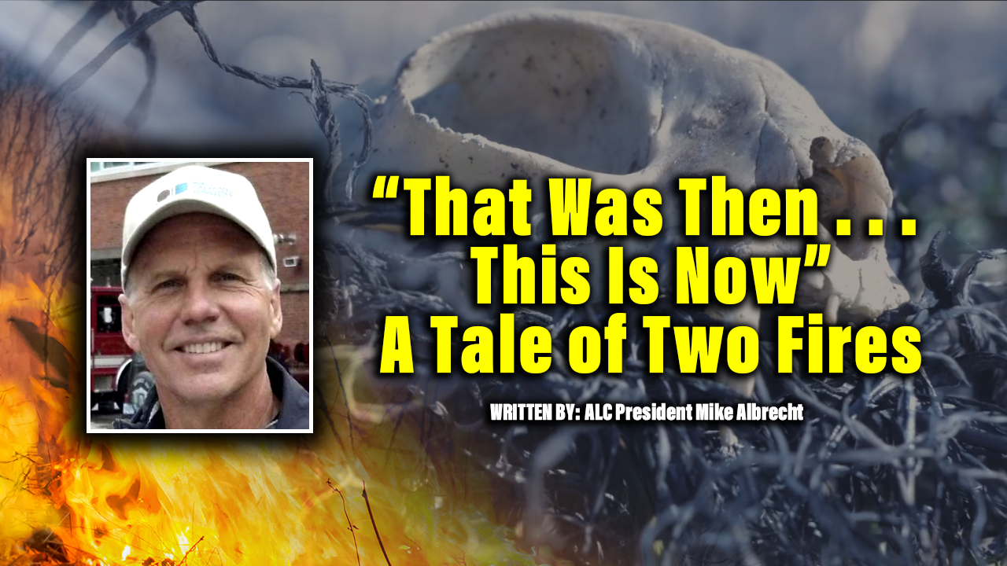

I’d like to start with a “thank you” to those of you taking the time to read this, and to keep you reading, I’ll share a quick joke that is pertinent to this topic . . . you’ll see why at the end.
A logger went to see his doctor. The doctor said, “Unfortunately, I have some bad news and some even worse news for you.” The logger nervously asked the doctor to give him the bad news first. “The bad news is you only have 24 hours to live.” The logger said, “What could possibly be worse than that?” The doctor said, “I should have told you yesterday.”
We’re going to take a look at two catastrophic western wildfires, the 1933 Tillamook Fire that burned on the Oregon Coast and the 2021 Dixie Fire that burned in Northern California. The following short description of the Tillamook Fire comes from a 320-page book titled “Tillamook Burn Country: A Pictorial History.” It is a comprehensive documentation of one of America’s most horrific wildfires written by Ellis Lucia.
The Tillamook burn raced through over 300,000 acres of mostly Douglas fir, and was described this way by a reporter: “From the summit of the Coast Range to tidewater lines, it is simply one vast and dense forest. It is a forest area of the giant breed, with trees ranging from eight to thirty feet in circumference, and reaching upward from 150-300 feet. In August of 1933, the Oregon coast weather was extreme, humidities dropped to record lows, and a bad fire that had been burning for several days “exploded with the ferocity of an H-bomb.” In twenty incredible hours the Tillamook Fire “rampaged over 220,000 acres, burning fine trees at an astounding rate of 600,000 board feet an hour.”

What occurred on that burn-scarred landscape in the following decades is truly a “legacy of achievement” by citizens, foresters and loggers. “The flames had hardly died and the embers cooled “when foresters and loggers launched what was one of the great salvage efforts of all time.”

At the time, the entire burn area was privately owned. To get this burn salvaged and restored, private timber interests met with local, state, and federal officials who all agreed to the formation of the huge Consolidated Timber Company. This was a bold cooperative enterprise at a time when such things were considered sinful, “almost bordering on Communism.” Consolidated immediately spent $1.5 million for railroad construction, $800,000 for truck roads, and $1.25 million for locomotives, cars, and rolling stock.

And so, the salvage and restoration began. When it was all over, 7.5 billion board feet of the estimated 10 billion board feet killed had been salvaged and converted to lumber. 73 million trees were hand planted with an additional one billion Douglas fir seeds dropped from helicopters. Although a private undertaking, the US Forest Service offered this advice and encouragement: “Measures to rehabilitate the burn should be taken, the cornerstones of which are intensive protection, hazard reduction, intensive salvage logging and reforestation.” There was no environmental impact statement written – the environmental impact spoke for itself.
Decades later, when all the salvage and restoration work had been completed, Ellis Lucia summarizes: “What once was a bleak desolate land is again alive and beautiful.”
THAT WAS THEN . . . THIS IS NOW.
On July 13, 2021, the Dixie Fire started in the Feather River Canyon of Northern California. When finally contained on October 25, the Dixie had burned through 963,000 acres of Sierra Nevada forests and became the most expensive wildfire suppression effort in US history, costing $637.4 million. The fire damaged or destroyed several communities including Greenville on August 4th, Canyondam on August 5th, and Warner Valley on August 12th.
Two years have passed since the Dixie Fire was contained. Estimates of the total timber destroyed range from 10 to 12 billion board feet on private and public timber combined. The bulk of the private timber has been salvaged. Upwards of 10 billion board feet of public timber remains standing, most of it worthless as lumber at this point. Between 2021 and 2024, the Forest Service Dixie Fire salvage program is estimated to yield 64 million board feet, or .64 percent of the burned timber. The Dixie Fire landscape is destined to rot, grow brush, and reburn.
There is no Ellis Lucia documenting the Dixie Fire story. The scenario that exists on the Dixie Fire today reflects the deterioration of forest management that has been quietly progressing through the western timber-producing states for over four decades, accelerating dramatically since the turn of this century. The extreme environmental groups are being allowed to “manage” our forests by litigation.
The end result is that grossly overcrowded forests rot from insect attacks and burn in catastrophic wildfires while America increasingly imports lumber from other countries. Consider this from the United States International Trade Commission: in 2020 the US imported $44.6 billion of forest products. 16% of US imports (over $7 billion) came from China, the country that is the leading importer of lumber in the world.
The logger sat before the California Legislature at a hearing called to discuss the condition of California’s forests. His testimony was quick and to the point. He told the chairman, “I have some bad news, and some even worse news for you.” The chairman asked the logger to tell the bad news first. “The bad news is that even though California is one-third forested, it now imports over 75% of its wood products. In 1985 California had 150 sawmills. Now, in 2023, only 27 sawmills remain. The chairman replied, “I had no idea . . . what could possibly be worse than that?” The logger said, “We’ve been telling you this for over 50 years. Now America, with almost 780 million acres of forests, is the second leading IMPORTER of lumber in the world, only behind China.
The joke I started with and the story of the logger both have bad news and then worse news, but the difference is, in the joke the patient has no hope. He dies. In the story of the logger, there is still some hope, but only if legislators and agencies recognize that time is getting short for our western forests and take bold action.
Like the legacy of the Tillamook, our legacy needs to be one of achievement. The apathy of “Dixie” stands in the way.
- Mike Albrecht, President, American Loggers Council
The American Logger – A Legacy of Achievement
Mike Albrecht has a master’s degree in forestry from Duke University, is a Registered Professional Forester in California, and has worked for over 45 years in forest management and the forest products industry.

Mike currently serves as president of the American Loggers Council and is a past president of Associated California Loggers and the Sierra Cascade Logging Conference.

